

**Pemrograman Berorientasi Objek**

INF3213

Kelompok 26

|  |  |
| --- | --- |
| **Projek UAS:Tetris**  Oleh:   * M.Gilang Romadhan 2111102441014 * Riya Nur Fadila 2111102441078 * Abimanyu Fewiyan Mahardika 2211102441187 |  |
|  |
|  |
|  |  |
|  |  |

Teknik Informatika Fakultas Sains & Teknologi Universitas

Muhammadiyah Kalimantan Timur

**UAS PBO : Tetris Game**

World class

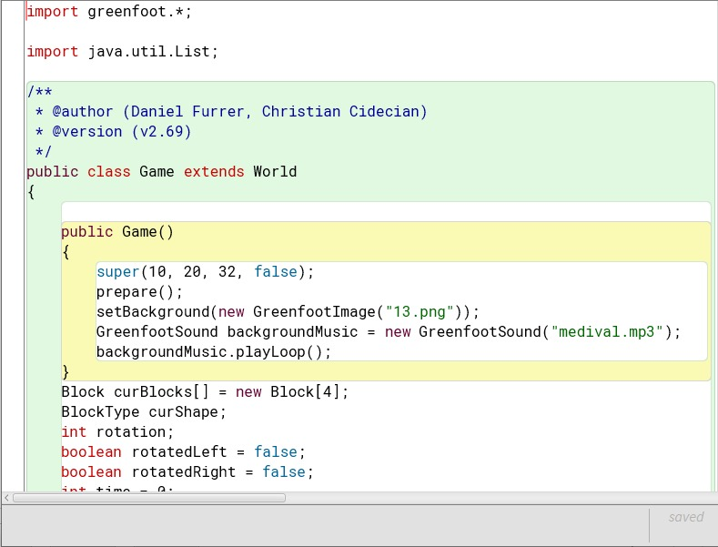

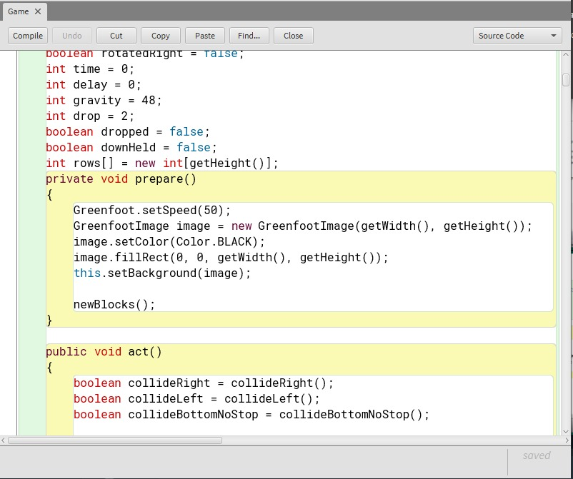





Actor Class

1. **Character**

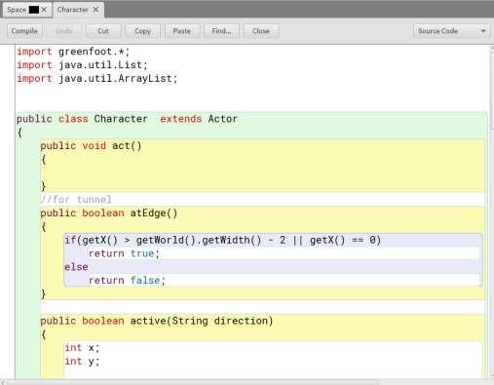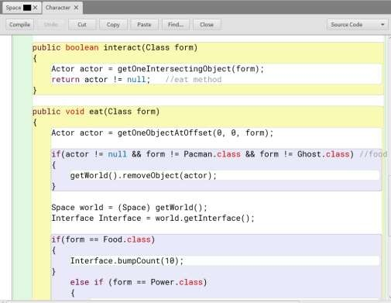

1. 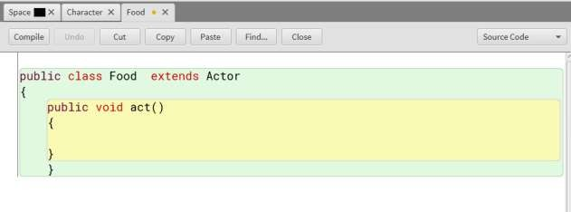**Food**
2. **Interface**

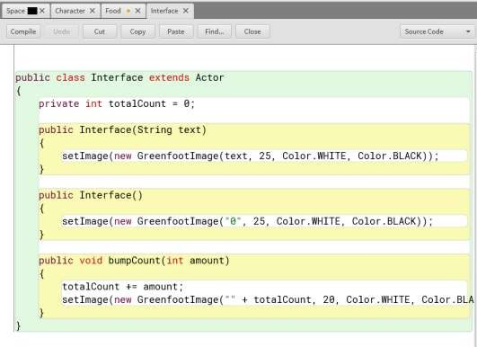

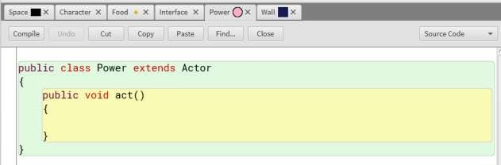c. Power

TAMPILAN

1. **Tampilan awal**

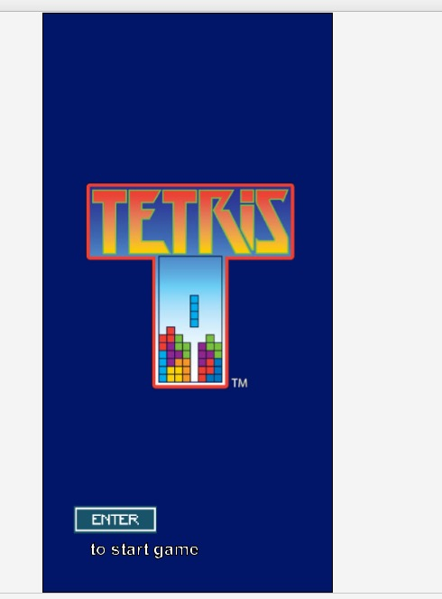

1. **Ketika dijalankan**

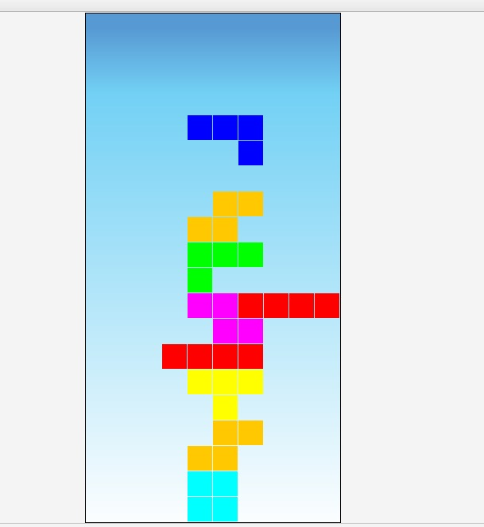

1. **Ketika game over**

